AGSouth Retail Pricing System
January 27, 2012

Table of Contents
Introduction 3
Services Provided 3
Retail Pricing 3
Retail Reports 3
AG Retail Pricing System Overview 4
Terminal Server Option 5
Launching the BRData Client 6
Item Lookup 7
Item Lookup – Search Options 7
Item Lookup – Control Tabs – Main Information 8
Updating retails 9
Item Lookup – Control Tabs – Labels / Templates 10
Item Lookup – Control Tabs – Options Tab 10
Item Lookup – Control Tabs – Miscellaneous 11
Item Lookup – Control Tabs – Movement 12
Item Lookup – Detail Grid 13
Item Lookup – Best Buys (top deals) 14
Item Lookup – Item Query 15
Export Item File and Labels 16
Export Item File and Labels - Query Tab 16
Export Item File and Labels - Export Tab 18
Export Item File and Labels - Options tab 19
Definitions 20
Pricing Rules 20
Grid Columns 20
Batch numbers 21
“How To” Guides 21
Review/Print Retail updates 21
Work Flow Example for in-store processing 22
Export Price Change Label File 23
Export BRData information to Excel 24
Print Weekly Price List 25
Shelf Label / Talker Layout 26
AG Retail Systems 27
AG Systems 27
In-Store systems 27
Help Desk 27

Introduction

The AG Retail Pricing Department continuously monitors major competition, cost changes and manufacturer’s allowances. Our goal is to improve each stores sales, gross profits and competitive image through a variety of pricing support programs.

The AG Retail Pricing Department maintains multiple house zones with pre-established pricing rules and works to optimize profitability within those rule parameters. AG’s Pricing Department is available to meet with store owners and zone managers to provide strategic direction for improved sales and profitability.

Services Provided

Retail Pricing

- Zone pricing is managed under specific category and item rules and enhanced using competitive price checks.
- New items follow the same category and item rules to insure “like pricing” on all line items.
- Retailers have the option to customize any suggested zone price to meet a local competitive situation.
- Flexible pricing rules allow retailers to “zone skip” by department and/or category.
- Rounding rules provide an additional opportunity for retailers to customize their retail price.
- A variety of shelf talker labels designed to increase sales, improve gross profits and enhance your stores competitive image are available.

Retail Reports

- Quarterly and Year-To-Date store item purchase reports sorted by department, category and item.
- A variety of “going-in” gross reports by store, by department or by category.
- Price comparison reports between current store pricing and major competitors.
- Top 500 and Private Label price checks provided on a rotating schedule of all major competitors.
- Zero purchase report and AG’s ranking for all items within each item’s category.
- Best Buy report providing the best buy opportunities available by department.
- Allowance report showing all items with current allowance and current inventory.

AG Retail Pricing System Overview

AG’s Retail Pricing System, which utilizes the BRData Software Program, is designed to provide the retailer with the tools necessary to manage retail prices and protect retail gross profits. Features of the program include:

- Retail Control of the system through the web.
- View and update retails directly on AG’s retail server.
- View competitive zones and AG house zones on line.
- Access store purchase history on line.
- Determine fastest/slowest selling items by category.
- View future retail price changes on line.
- Download files to MS Excel program.
- Print shelf talkers and shelf labels at store level.

- Access to AG warehouse information through the web.
- View AG warehouse 13 week movement by item.
- View current layer cost and replacement cost.
- View current layer inventory levels.
- View Best Buys by department/category ranges.
- View all current deal information.

- Retail cost changes once a week.
- Retail changes based on AG’s replacement cost.
- Shelf tags printed only for items the store carries.
- Stops incidental price changes (.01 or.02 cents).
- A variety of rounding rules available.
- Supports multiple shelf tags for items, i.e. front-end candy.
- Competitive price checks completed on a rotating basis.

- Shelf Talker program including TPR, Compare & Save and EDLP Talkers.
- Creates a competitive price image for the store.
- Improves sales and gross profit dollars.
- Provides a controlled method for passing on deals.
- Highlights and improves sales of Private Label items.
- Store specific TPR and C&S parameters.
- Store specific EDLP Shelf Talker program available.

- Download file for store front-end system available.

- No weekly charge if store prints their own shelf tags and shelf talkers.

Terminal Server Option

For users running Windows XP with service pack 3 updates or Windows vista with service pack 1 updates, the retail pricing system can be launched from the AGSouth SharePoint server remotely through the Internet Explorer web browser. This gives the benefits of not having to install a local copy of the software and having a significant speed increase in processing data. These benefits are realized by the actual software being run on the main server at the AG warehouse and only visual screen updates being sent back to the user’s local machine.

The SharePoint server can be accessed by entering http://brdata.agsouth.com into the address bar on Internet Explorer.

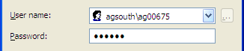
A login screen will ask for the user name and password. The user name will be the same user name used to access the main AGSouth website preceded by the domain “agsouth\” (example: user AG00675 will be entered as agsouth\AG00675 for the user name).

The main SharePoint site will be used for notices to the users. A tab labeled BRDATA will give the user access to the retail application.

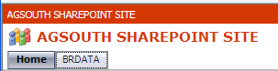

The remote applications available are the main BRData program, Windows Explorer, and a Mail to Self utility.

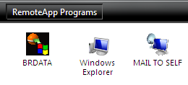
The BRData remote application functions identically to the local AGSouth application install covered in detail in the rest of this document.

The Windows Explorer application will give the remote users access to files created on the SharePoint server for a copy/paste capability to their local machine.

The Mail to Self utility will collect any created label files and email them to your @agsouth.com email account.

Launching the BRData Client

The AGSOUTH icon is used to launch the BRData Client. This program is used to view item information, change the retails on the items, report on groups of items, and export batches for printing.
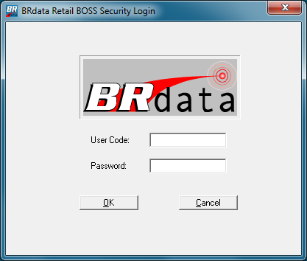

Clicking on the AGSOUTH icon will bring up the BRData login screen you see to the right. Here you will enter your Username and Password and click the OK button.

Multiple user logins for a store are available upon request. Benefits are:
- View only option
- Track if multiple people are making updates.

The client program will connect to the server at the AG Warehouse and bring up the main BRData screen as seed below.

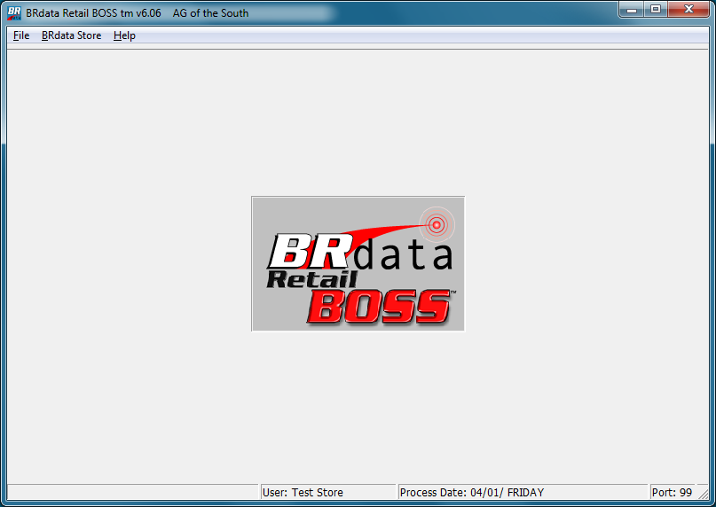

Item Lookup
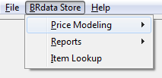

Selecting the menu option BRdata Store will drop down a sub-menu list. From this list, select the Item Lookup menu option to open the Item Lookup screen.

Item Lookup – Search Options

Items can be searched in different ways by selecting the type of search from the drop-down list in the item search area.

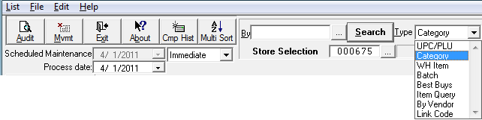

- UPC/PLU search allows the UPC from the product to be keyed.
- Category search displays the items within that category.
- WH Item search allows the AG item (ordering number) to be keyed.
- Batch search displays all items within a specific batch.
- Best-Buys search display items where layer cost has the best savings compared to replacement cost (refer to Best Buys section).
- Item Query allows further options for search selection (refer to Item Query section).
- By Vendor search is used to get all items for a vendor. This is not used on our system as all items fall under a warehouse level (AGS or MLB) vendor.
- Link Code search displays all items under a specific link code.

A listing of different codes can be displayed by clicking the […] button to the left of the search button. When performing either a category search or a link code search, a listing of the available AG category or link codes will be displayed.

The Store Selection option will allow a user that has access to a multi-store group move from one store to another.

There are several large buttons on the top left that give the user access to extra information about the selected item.
- Audit will bring up a new window with an audit history of past changes to the item.
- Mvmt will bring up a new window with purchase history information on the item.
- Exit will close the Item Lookup screen and return to the main menu.
- About will bring up an information screen with details about the application.
- Cmp Hist is not used.
- Multi Sort will bring up a new window for selecting options for sorting the data grid.

Item Lookup – Control Tabs – Main Information

The Main Information tab gives the user access to retail control, detail information on cost and TPR, and the inventory cost layers associated with the item selected from the detail grid.

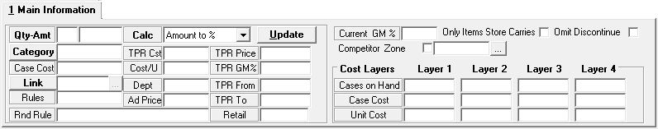

The Qty-Amt and Calc fields and the Update button are used for retail control. See the next section below for details on retail control.

Dept, Category and Link codes show the different levels of grouping on the item.

Case Cost and Cost/U are the actual delivered costs per case and unit.

TPR Dates, Cost, GM% are displayed for all items with deals. TPR Price (Regular Retail less the unit deal amount) is displayed only if the TPR qualifies. Ad Price will display an amount if the item is currently in an AD batch.

Current GM% is based on current cost, current retail, and if a single unit was purchase for every item being displayed in the grid.

The “Only Items Store Carries” and “Omit Discontinue” checkboxes will allow the user to hide or display items not currently ordered by the store or no longer supplied by the warehouse by checking or un-checking either box.

The “Competitor Zone” checkbox will include the competitor retail information in the detail grid. Available competitor zones and house zones are listed by clicking the […] selection box.

The information that appears in the “Cost Layers” section is updated daily. “Cases on Hand” shows the current warehouse inventory for the selected item. Case Cost & Unit Cost are the delivered costs to the store. For the layers that are displayed, Layer 1 is always the lowest price. Layer 4 displays the Replacement Case cost which is what the retail is based upon. CRC Deal is a count & recount deal that will lower the layer cost if billed by the date shown.

In the example below, the unit cost would be lowered by 77 cents if billed by 04/13/2011 making the invoice cost only $1.002 per unit ($12.02 per case).

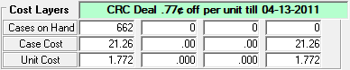

Updating retails

Retail updates can be done for a single item selected from the detail grid or for a range of items. To select a range, click on the first item, and then while holding down the shift key, click on the last item. To select several items that are not in line together, click on the first item, then while holding down the Ctrl key, click on each item that needs to be selected.
Please note that if there are a lot of items displayed on the grid at once, it may be faster to change them one time. If only one item is changed at a time, the grid is updated locally, when a multi-select update is performed, the grid is completely re-loaded.

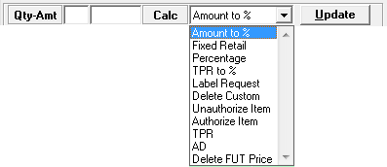

The first field to the right of “Qty-Amt” is the retail quantity break.

The second field is the retail dollar amount.

To the right of “Calc” is a drop down box with the following options:

- Amount to % - Enter a qty/retail wanted on the item and a percentage rule is created that moves the retail with changes in cost.
- Fixed Retail – Enter a qty/retail wanted on the item and it will remain until a new qty/retail is entered.
- Percentage – Enter a percentage amount and a new retail will be calculated from the percentage which will adjust with changes in cost.
- TPR to % - If an active TPR exists for this item, this will accept any entered target retail for the TPR and adjust the regular retail to match. The regular retail will then adjust with changes in cost.
- Label Request – No retail change is involved, only a label is generated with the current retail. The number of tags needed for the selected item is entered into the retail quantity break box. Any number larger than 1 is stored and used for all future label printing.
- Delete Custom – Remove a custom “store level” override (SUM/SUF) from an item. This will allow the rule to fall back to the default rules used by the zone.
- Unauthorize Item – Will remove item from store “activity”. An unauthorized item will not show up on any screens or reports of “just what the store carries” and will no longer have labels generated when updates happen on the item cost.
- Authorize item – Will add an item to store activity. Authorized items will show up on screens and reports of “carried” items and will begin receiving labels when cost changes occur.
- TPR and AD – These options allow the user to set custom TPR and AD prices with start and end dates.
- Delete FUT Price – Unused at this time.

To apply a change to the item, click on the “Update” button. As changes are made to items, a batch is created to hold each change. Once all changes have been completed, exit the Item Lookup screen and return to the main BRData screen.

Item Lookup – Control Tabs – Labels / Templates

The Labels / Template tab gives the user access to label type and label quantity control and also displays the compare and save information on the selected item.

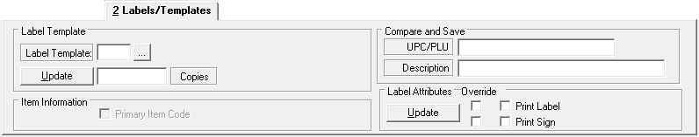

To update type of label, click on the […] button to display the list of labels template codes.
Select the code for the new label type from the listing. Click the Update button to apply the change. Please note that this sets the change for any future label generated.

To update number of copies printed at a time for a label, change the number of copies and click on the update button to apply changes. This will also require a label template to be set.

The” Compare and Save” section will display the UPC code and description of the comparison item that is linked with the selected item.

The “Label Attributes” section is not used at this time.

Item Lookup – Control Tabs – Options Tab

The Options tab gives the user access to various search modification options that expand or limit the items that appear in the detail grid.

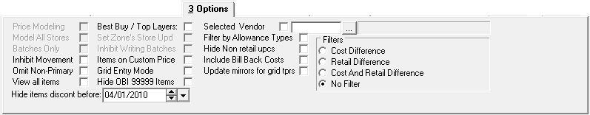

When selected, the Omit Non-Primary checkbox will remove any Non-Primary UPC codes from the detail grid. When a UPC code is changed for a warehouse item, the computer keeps track of both the new and the original UPC numbers to manage retails. The new UPC will be considered the Primary number and the previous UPC will be considered the Non-Primary. Non-Primary UPCs will be shaded in gray in the detail grid. Normally this box should be checked.

Item Lookup – Control Tabs – Miscellaneous

This tab gives the user access to more item information.

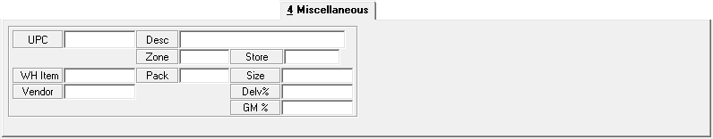

Information shown on the miscellaneous tab includes the UPC, warehouse item, description, pack and size. The store, delivery fee, base zone and the rule being followed to calculate the retail is displayed (refer to the definitions section for pricing rules for details). The gross margin percentage is also displayed.

Item Lookup – Control Tabs – Movement

The movement tab gives the user access to the 4 week purchase history and allows the user to change the movement totals that appear in the detail grid.

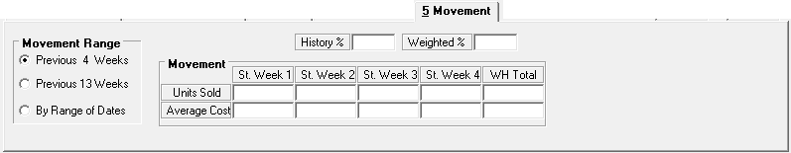

Movement totals displayed are the number of units purchased (cases purchased times the case quantity).

The “Movement Range” selection allows the user to change the movement totals displayed in the detail grid from the default 4 weeks which is fastest processing of information. The user may select the previous 13 weeks or select the movement totals to appear by a range of dates. The date range selection allows the user to set starting and ending date. The movement shown in the grid is the total units purchased for the number of weeks that is selected.

The movement tab also shows the history and weighted margins for the listing of items that are currently displayed in the detail grid.
- History % is based on the history movement file. It uses actual invoice cost, actual invoice retail and quantity purchased on the invoices for the items being displayed.
- Weighted % is based current cost, current retails, and actual purchases from the history movement file for the items being displayed in the grid. This is the “PROJECTED MARGIN.” It is recommended to use previous 13 weeks movement selection.

To determine which items to discontinue or add for a category or which items are your faster movers for a category utilize this feature:
- Set the Movement control to 13 weeks
- Make sure Omit Discontinued flag is not checked
- Make sure Only Items the Store Carries flag is not checked
- Select the category of items to be displayed in the grid
- After items are displayed, click on the “WH Move” column or the “St Move” to sort the items in the grid based on warehouse movement or store movement.

Comparing the store and warehouse movements will give you an idea of how your store purchases line up with the total purchases from all stores from the warehouse

Item Lookup – Detail Grid

The Detail Grid covers the lower area of the item lookup screen. Higher resolution screens will allow the detail grid to expand and show more information without having to scroll the grid.

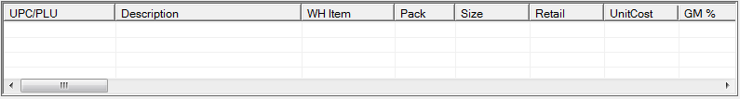

The detail grid behaves the same as many windows applications in that it allows the user to adjust the appearance of the grid. By clicking and dragging within certain areas in the header of the grid, the user can resize the width of columns and drag them into different orders.

The “List” menu allows the user to save and retrieve predefined column arrangements for the grid. To save a customized grid layout, arrange the columns and save this arrangement so that the description identifies your store number. All stores have access to the grid arrangement list and stores can see and use arrangements that have been saved.

A click on a column header will sort the list of items in ascending or descending order of that column.

Printing the Items in the Grid

- Make sure the grid looks exactly the way you want it to print.
- Click on List & Printer Selection-Setup - set to Landscape.
- Click on Print Preview to verify it looks okay.
- Click on Print to print report.

This is an easy way to generate a list of items.

Item Lookup – Best Buys (top deals)

This search option is used to identify the items with the best deals or buys by utilizing the percent of savings. This is determined by comparing the current inventory cost to the current vendor’s list cost. The items with the highest percentage of savings are displayed first in the grid.

Make sure the following flags are checked in the Options Tab:
- Omit Non-Primary
- Omit Discontinued
- Only items the store carries
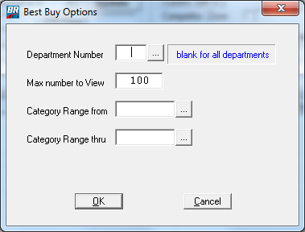

Select “Best Buys” from the search drop-down listing and click the Search button.

A Best Buy Options window will pop up for the user to enter search options.

A specific department can be selected from the […] listing or it can be left blank for all departments.

The total number of items displayed can be adjusted from the default of 100. For performance reasons, it would be best to keep the number to view to 100 or less.

The detail grid will automatically display the items with the best savings first.

By highlighting an item, the actual layer information is displayed. The “M” in the Best Buy column signifies that the item has multiple layers.

Because we are a co-op and sell the lowest cost inventory first, it is important to check inventory level when deciding which item to consider.

Item Lookup – Item Query

The Item Query search option is a more flexible search that allows multiple search criteria to be used in selecting items. Select “Item Query” from the search drop down list and click the search button to display the new query window.

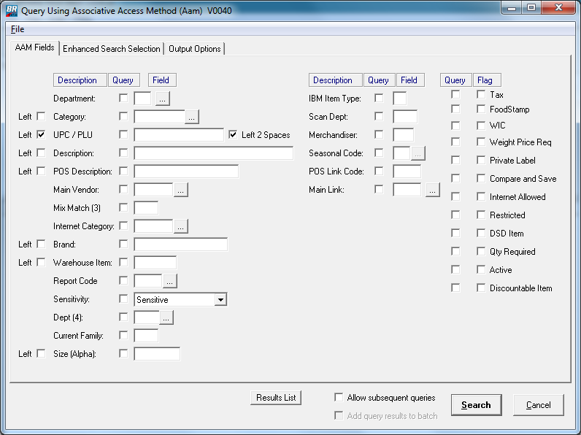

To use a search field, put a checkmark in the Query column and either type a search item in the field or select one from the […] listing. Click the Search button to retrieve items.

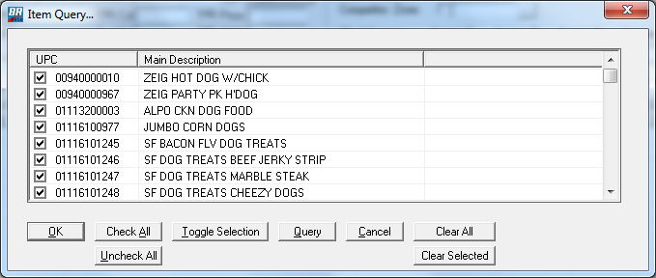
Example:
Check the query box for description and type the word “DOG” in the field.

The program then displays a list of items. You can exclude items by un-checking them.

Click the OK button to display the selected items in the detail grid. This is a very dynamic way to select items.

Export Item File and Labels

Exporting an item file is a powerful tool to extract data from BRData and view the information in various ways, such as:
- Extract batches to view/print items that are having price changes
- Extract batches to download to the store’s POS system
- Extract batches to print shelf tags/talkers
- Print price list for all or selected items
- Print list of items with “Fixed” prices for retails
- Print list of all items with TPRs
- Extract item records into CSV files for Excel

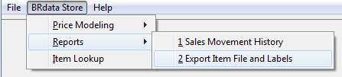
Select the menu option ISA-2000, Reports, and then “Export Item file and Labels” to open the Export Item Information screen.

Export Item File and Labels - Query Tab

The Query tab allows the user to select how the items are to be reported and/or exported.

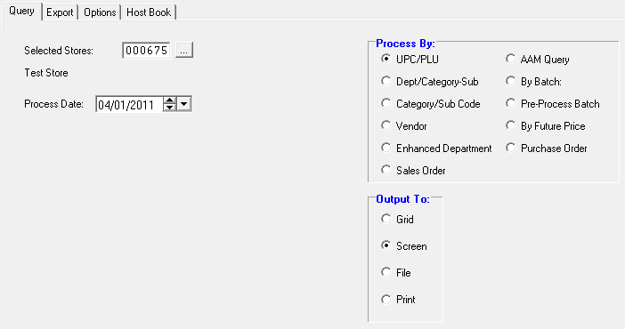
The Selected Store does not change unless the user has access to a store group. It will automatically default to your store.

Process Date needs to be set only if exports are being done on a batch dated for later in the week. Then this date will need to be set to the start date of the batch.

The “Output To:” selection default to the screen and will change automatically when other options for exporting files are selected.
The “Process By:” options are where the user has control over the item selection.

Selecting to process by “UPC/PLU” will pop up a new window.
Make sure to uncheck the “All UPCs” box.
Key the lowest UPC into the “From” field and the highest UPC into the “To” field.
Click the OK button to apply selection.

Selecting to process by “Dept/Category-Sub” will pop up a listing of departments.
From the department listing window, check each department needed.
Click “Accept” to apply department selections.

Selecting to process by “Category/Sub Code” will pop up a listing of categories.
- The Group Selection button allows several categories to be grouped together, then that group can be selected.
- The Range Selection button allows from & to selection.
- Alpha Search is used to find a category by description.
From the category listing window, check each category needed.
Click “Accept” to apply category selections.

Selecting to process by “AAM Query” will open a new list window with a query button. Clicking the query button will give a search screen similar in functionality to the one from the item lookup screen.
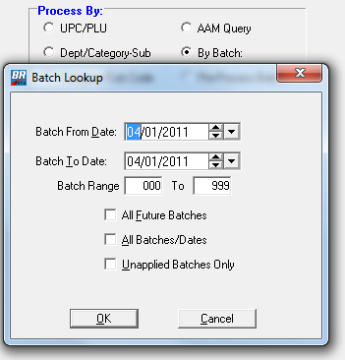
Selecting to process “By Batch” will open a batch lookup window. From this window you can select a specific day or range of days, limit the batch numbers listed to a specific range, see all future batches or all batches held in the system.

Select the ranges need to limit batch listing and click the OK button to get a list of batches that meet the criteria.

To select a batch from the listing, click the batch to highlight and click the O button to apply. You can select multiple batches by holding down the shift key and clinking to select a range or the control key and clicking on each individual batch.

The number of changes for each batch displayed on the screen is for all stores, not just your store. Selecting a batch will return no items if your store had no items within the batch.

Batch numbers 800 – 816 are the automatic batches for all stores. Other batches are special batches. Normally, batch numbers in the 801 to 816 range are used for shelf label printing.

Export Item File and Labels - Export Tab

The Export tab allows the user to select to have the item information that is generated placed into a disk file instead of a displayed or printed report.

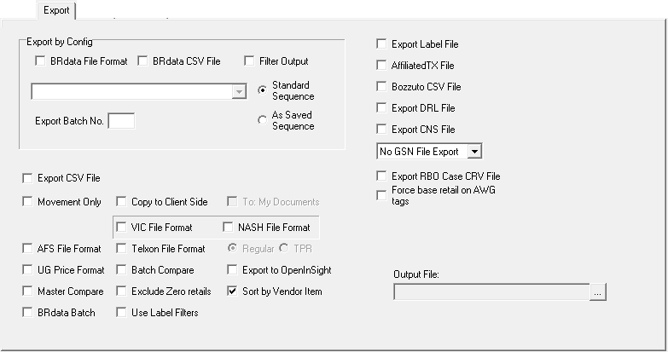

The two export options used by AG are the “Export Label File” checkbox on the top right and the “Export CSV File” in the center on the left.

The option to export a label file is used when extracting data for a label or sign printing program. This format contains many fields specific to the printing of shelf tags and talkers.

The option to export a CSV file is used when extracting data to be used in an application such as Excel for reporting or some front end system host processing.

The “Copy to Client Side” option will should always be checked in order to move the file generated from our server to your local machine. The “To My Documents” option, when checked, will place the file into your “My Documents” folder for easy location.

Other export options not mentioned are generally not used by AG.

Export Item File and Labels - Options tab

The Options tab allows the user to set some options which affect the data being generated.

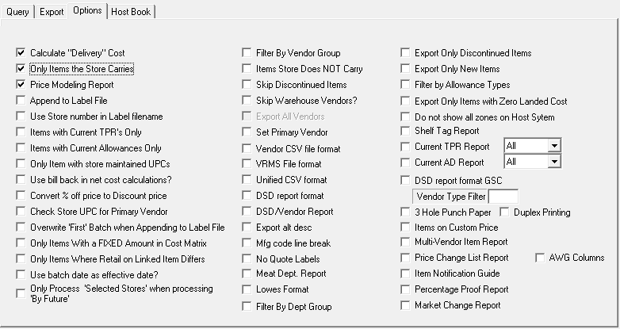

There are recommended defaults that a new user should set on this screen and then save permanently by clicking the “Save” button at the top of the screen. These defaults should be set:
- Calculated Deliver Cost:
- Only items the Store Carries
- Price Modeling Report:
The option for “only items the store carries” should be turned off only if a listing of all available items in the warehouse is needed.

Other useful options that can be set include:
- “Items with Current TPR’s Only” will select all items with an active TPR retail.
- “Items with Current Allowances Only” will select Items having a active deal.
- “Only Items with a Fixed Amount in Cost Matrix” will select items with a fixed retail rule.
- “Only Items Where Retail on Link Item Differs” will select items within a link code group where the retails do not match between items.
- “Skip Discontinued Items” will leave out discontinued items.

Definitions

Pricing Rules

Each rule is broken down into a 3 character type.
- First character determines where the rule originated:
z = AG zone
s = store custom override
- Second character determines the level of the rule:
u = UPC level override
s = subcategory level override
d = department level override
- Third character determines the type of rule:
M = margin; On percentage basis to reflect cost changes
F = fixed; retail is set and will not change automatically
Examples:
suf = Store has a UPC level override on the item for a fixed amount retail.
sum = Store has a UPC level override on the item for a percentage.
sdm = Store has a department level override for a percentage.
zdm = Item is following the AG zone department level percentage.
zum = Item is following the AG zone UPC level percentage
zuf = Item is following the AG zone UPC fixed amount retail

Grid Columns

UPC: Item UPC/PLU code.
Description: Item product description.
WH Item: Warehouse order code.
Pack: Number of items in a case.
Size: Size of an individual unit of the item.
Retail: Current calculated retail amount for the item.
Unit Cost: Current cost, with fees, for a single unit of the item.
Link: Like-item link code to determine items of the same type.
GM%: Gross margin determined between unit cost and retail.
TPR: Retail from a Temporary Price Reduction (allowance).
From: Start date for the TPR.
To: End date for the TPR.
Net Cost: Cost of the item after the TPR allowance.
Rules: Rule Type to determine the origin of the rule.
Rules: Number that represents the actual percentage, retail, etc.
GM%: Gross margin determined net cost and TPR.
Dept: Warehouse department where the item is located.
Category: Category/subcategory breakdown within the department.
Vendor: Vendor code (AGS = Associated Grocers).
Move Qty: Unit movement from ordered product. (Either 4 or 13 weeks)
MvAvgCost: Average unit cost for the select movement range.
ComPrc: “Competitive pricing” retail for the current selected competitive zone.

Batch numbers

800 Cost Change – all cost changes regardless if retail changed or not
801 Price Decrease
802 Price Increase
803 Produce Changes (occurs separately on Tues/Thurs)
808 Tag (label) request
810 Custom Retail
811 New Purchases from orders
812 Price Load (new items from movement)
813 TPR off
814 TPR on
815 Compare & Save
816 Discontinued Item

“How To” Guides

Review/Print Retail updates

Retails are recalculated for cost changes for all items on Friday and Saturday. Saturday is a “catch-up” day for late changes that might happen on Friday. Retails for Produce cost changes are also recalculated on Tuesday and Thursday. All items that have a new retail due to a cost change are put into batches. Items can be reviewed in BRData by these batch numbers (See definition of Batch numbers for details).

From within the BRData system:
- Select menu options BRdata Store | Reports | Export Item File and Labels
- On the "BRData Host Export Item Information" screen:
- On the "Query" tab, select to process "By Batch:”
- In the "Batch Lookup" dialog window, set the start/end dates for Sunday and the batch range from 801 to 816. Click the OK button.
- In the "Select Batch(es) to export" dialog window, select batches by clicking on the first batch and then holding down the CTRL key on the keyboard and then clicking on each of the other batches needed. Click the [OK] button when done, and click the [Yes] button on the "Confirm Process" dialog window.
- On the "Options" tab, make sure to check "Calculate Delivery Cost", "Only print the items the store carries", and "Price Modeling Report".
- On the "Query" tab make sure that the correct store number is shown. And change the "Process:" date ahead if exporting a future dated batch.
- Click the [Process] button at the top of the window to begin the report generation.
- Once the report has been generated, the "Print Preview" window will appear. This window allows the data to be reviewed before printing.
- The [Zoom In] and [Zoom out] buttons will increase and decrease the print.
- The [Next Page] and [Prev Page] buttons allows scrolling through a report by pages
- The [Go To] button allows you to jump immediately to any page number.
- The [Print] button will print the report and close the "Print Preview" window.
- The [Close] button will exit the "Print Preview" window without printing the report.

The correct time to review the new retails from cost changes is the time between when the retails are recalculated for cost changes and when the labels/talkers are printed. Please refer to table below. If labels/talkers are printed at the stores then it would be any time after the retails are recalculated and when the store prints them.

If labels/talkers are printed at AG, then refer to printing time shown in the table.

Day | Depart. | When BRData Retail is recalculated for cost changes | When Billing system will use new Retail | When shelf tags are printed at AG
Tuesday | Produce | before 9:00 am | Tuesday 11:00 am | Tuesday 11:00 am
Thursday | Produce | before 9:00 am | Tuesday 11:00 am | Tuesday 11:00 am
Friday | All | before 9:00 am | Saturday 3:00 pm | Sunday 7:00 am
Saturday | All | before 9:00 am | Saturday 3:00 pm | Sunday 7:00 am
**** Note: all times are in Central Standard Time

Also note that in order to have the retail changes take effect for billing, the changes must happen before: 11:00 am (CST) Monday- Friday for Perishable billing
5:30 pm (CST) Saturday for Sunday morning Perishable billing
5:30 pm (CST) for Grocery Billing (every day)

Work Flow Example for in-store processing

This table is an illustration of work that needs to be done to manage retails at store level. This example is based on if the store has a late Monday delivery and an early Thursday morning delivery. Also the tags/talkers are printed at AG and not in the store.

The Pricing Coordinator and the Pricing Manager may or may not be the same person.

Day | Who | Time | Job Duty
Sunday
Monday
Tuesday | Pricing Coordinator | Early Morning | Separate Shelf Tags (majority of tags will be this day)  Work all tags/talkers except “TPR off” and “TPR on” - apply changes with RF unit after each tag is placed on the shelf. Excluded TPRs Off & On for now.
Wednesday | Pricing Coordinator | Early Morning | Work with TPRs batches from day before.  Retail changes are applied with RF unit after each tag is placed on the shelf.
Wednesday | Pricing Manager | Every 8 weeks | After Pricing Coordinator has made all the price changes pull file off the Front-End system and send to AG for Front-End Price Audit. AG will run the audit comparison. Store has the option to have a list of the discrepancies or a tag request can be automatically generated for the discrepancies.
Thursday | Pricing Coordinator | Early Morning | Separate Shelf Tags (should be just a few tags)  Retail changes are applied with RF unit after each tag is placed on the shelf. Including TPRs.  Audit prices on one aisle in the store. (rotate aisle each week)
Friday | Pricing Manager | Between 9:00 am & 5:00 pm | Review Retails changes from Cost Updates for all departments. Refer to IX. How To: Review/Print Retail Updates (page 22)
Saturday | Pricing Manager | Between 9:00 am & 5:00 pm | Review Retails changes for Late Cost Updates for all departments. Refer to IX. How To: Review/Print Retail Updates (page 22)

If price batches are downloaded automatically to the front end, the price changes should be done when there is very little traffic in the store.

If the store is busy, then separate the “Price Declines” and “TPR-on” from the rest of the batches. For “Price Declines” and “TPR-on” batches, change the front-end system first, then: hang the tags/talkers. For all other batches, hang the tags/talkers, then: change the front-end system.

Following this approach, the customer will always pay the lower price in the transition between the old retail and the new retail.

Export Price Change Label File

To export the items in the end-of-week processes in order to print labels, the following steps can be run anytime after 12:00 pm (CST) Saturday. This will ensure that all changes from Friday and Saturday are included in the label file.

From within the BRData system:

- Select menu options BRdata Store | Reports | Export Item File and Labels
- On the "BRData Host Export Item Information" screen:
- On the "Query" tab, select "By Batch".
- In the "Batch Lookup" dialog window, set the start/end dates for Sunday and the batch range from 801 to 816. Click the OK button.
- In the "Select Batch(es) to export" dialog window, select batches by clicking on the first batch and then holding down the CTRL key on the keyboard and then clicking on each of the other batches needed. Click the [OK] button when done, and click the [Yes] button on the "Confirm Process" dialog window.
- On the "Options" tab, make sure to check "Calculate Delivery Cost", "Only print the items the store carries", and "Price Modeling Report".
- On the "Query" tab make sure that the correct store number is shown. And change the "Process:" date ahead to Sunday if exporting on Friday or Saturday.
- On the Export tab check "Export Label File" and "Copy File to Client Side"
- Click the [Process] button at the top of the window to begin the batch export.
- Click the [OK] button on the dialog for "Completed Export of Label File"
- Click the [OK] button on the "File will be copied" dialog.
- Click the [OK] button on the "File copy completed" dialog.

Now the label file has been created and transferred over to your local C:\BRDATA folder and is ready to be imported into your sign/label software to be printed.

Export BRData information to Excel

To use Excel for the creation of custom reports, a CSV (comma delimited) file can be exported from the BRData system. Excel can open a CSV file in a spreadsheet format which will allow the user to control the information to create completely customized reports. To export end-of-week batch information from BRData into Excel follow these steps:
From within BRData:
- Menu options BRdata Store | Reports | Export Item File and Labels
- On the "BRData Host Export Item Information" screen:
- On the "Query" tab, select "By Batch".
- In the "Batch Lookup" dialog window, set the start/end dates for Sunday and the batch range from 801 to 816. Click the OK button.
- In the "Select Batch(es) to export" dialog window, select batches by clicking on the first batch and then holding down the CTRL key on the keyboard and then clicking on each of the other batches needed. Click the [OK] button when done, and click the [Yes] button on the "Confirm Process" dialog window.
- On the "Options" tab, make sure to check "Calculate Delivery Cost", "Only print the items the store carries", and "Price Modeling Report".
- On the "Query" tab make sure that the correct store number is shown. And change the "Process:" date ahead to Sunday if exporting on Friday or Saturday.
- On the Export tab check "Export CSV File" and "Copy File to Client Side".
- Click the [Process] button at the top of the window to begin the batch export.
- Click the [OK] button on the dialog for "Exported Items to CSV File".
- Click the [OK] button on the "File will be copied" dialog.
- Click the [OK] button on the "File copy completed" dialog.
Now the CSV file has been created and transferred over to your local C:\BRDATA folder and is in a format that is ready to be opened with Excel.

From within Excel:
- Menu options File | Open
- In the "Open" dialog, drop down the "Look In:" list and select the "Local Disk (C:)" drive. A listing of folders on the C: drive should appear. Double-Click the "BRDATA" folder to retrieve a list of the files within it.
- Use the "Files of Type:" drop-down list to locate and select "Text Files ( *.txt, *.csv )" to display the CSV (comma delimited) export file. Locate the "BRDATAXL.CSV" file and double-click it to load the information into the Excel spreadsheet.

You now have the batch information loaded into an Excel spreadsheet. From here you can work with the information to customize your own reports.

Print Weekly Price List

To print a price book of items in the BRData system, the following steps can be run at any time. To make sure that all items that have changed for the week are updated correctly, it is best to run a new price book for the week after 12:00pm on Saturday.

From within the BRData system:
- Select menu options BRdata Store | Reports | Export Item File and Labels
- On the "BRData Host Export Item Information" screen:
- On the "Query" tab, select "Department/Category-Sub"
- In the department code dialog window check the departments you would like to have in the price book. Click [OK] when done.
- On the "Options" tab, make sure to check "Calculate Delivery Cost", and "Price Modeling Report". If you only want a list of items that are active for your store, check “Only print items that the store carries”. If you leave the box unchecked, you will print all items with non-active items showing no retail.
- On the "Export" tab make sure that the correct store number is shown and change the "Process:" date to Sunday if running on Friday or Saturday to match the end-of-week batch date.
- Click the [Process] button at the top of the window to begin the report generation.
- Once the report has been generated, the "Print Preview" window will appear. This window will allow you to browse through the report on-screen before printing.
- The [Zoom In] and [Zoom out] buttons will increase and decrease the font size to allow a better view or more information on screen.
- The [Next Page] and [Prev Page] buttons scroll through the report a page at a time.
- The [Go To] button allows you to jump immediately to any page number.
- The [Print] button will spool the report to the printer and then close the "Print Preview" window.
- The [Close] button will exit the "Print Preview" window without sending the report to the printer.

Notes: Other “Options” that can be useful while printing price books are:
“Only Items with a FIXED Amount in Cost Matrix” – This option will generate a price book list that only prints the items that have a UPC CRIP override to a FIXED amount. This helps to track sensitive items marked for competitive pricing.
“Items with Current Allowances Only” – This option will generate a price book list that only contains “Deal” items which are currently active.

Shelf Label / Talker Example

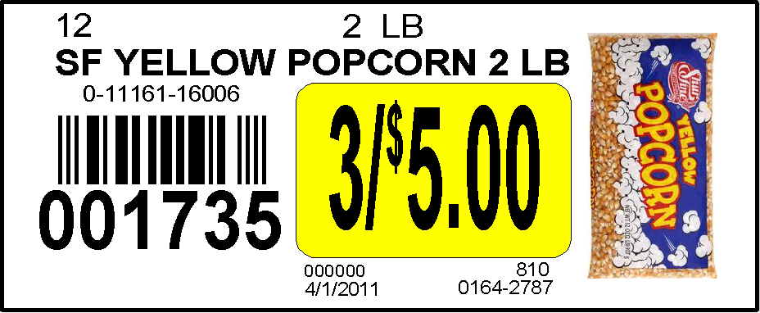

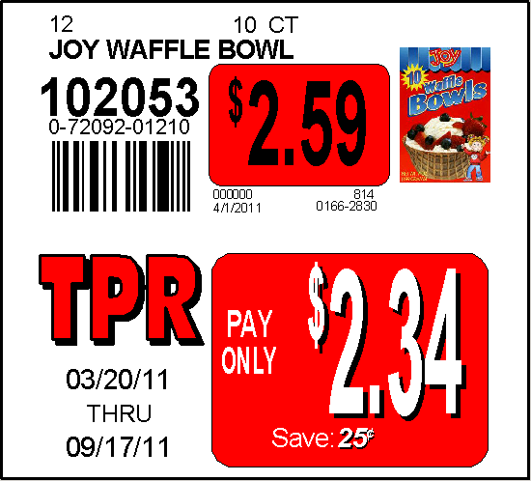

AG Retail Systems

The Information Technology (I/T) area of Associated Grocers of the South is ready to help the grocery retailer meet their needs for retail systems for today and the future.

Services Provided

AG Systems
- AG’s Web Site
- Up to date Merchandise News
- AG Store Email accounts
- Web Surveys
- Electronic Invoices, Credits, Statements, and Booking - Survey Recaps
- 7 years history
- Search capability
- Real Time Training available through the web
- BRData - web access training
- Microsoft Office Products training via Skillsoft training system
- BRData Retail Pricing
- Retail Pricing Control
- Online Movement History
- Tag/Talker control
- Export & Printing reports
- Item Movement Comparison reports
- Contract Negotiations
- Credit, Debit, EBT contracts
- Satellite contracts (EchoSat)
- Desktop Training (Word, Excel)

In-Store systems
- Consultation for systems
- Downloading POS pricing files
- Front End (POS) Price Audits
- Printing Signs, Tags and Talkers
- Customized Talkers
- Customized Signs
- Support for Satellite installations
- In-Store Training – AG systems
- Time & Attendance systems

Help Desk
- Billing Review
- Missing Orders
- Late Orders
- High/low quantities
- Support for Hand Held Order Entry Machines
- 7 day a week support

